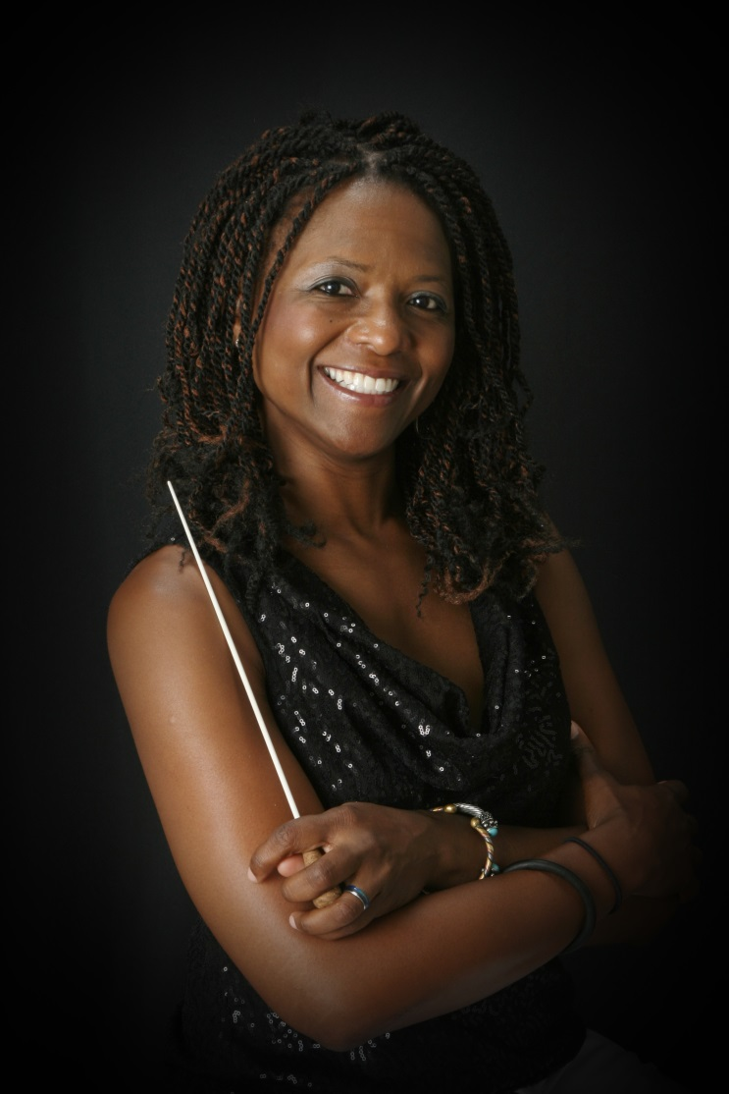
Veronica Jackson -
Educator, Conductor,
Violinist
After graduating from W. G. Enloe - Magnet High School (Raleigh, North Carolina) in 1985, Ms. Jackson studied violin at the University of Miami (Coral Gables) with Dr. Marla Meutschler (Paul Rolland protégé) and Dr. Earl Sanders at North Carolina Central University (NCCU). Graduating summa cum laude from NCCU in 1991, she began teaching orchestra in Wake County elementary, middle, and high schools in Raleigh, North Carolina. Ms. Jackson moved to Richmond in 1994 and began teaching in Henrico County Public Schools, where she worked for 17 years at several schools including Byrd Middle School, Godwin High School, Freeman High School, and Tucker High School. In Henrico County, she coordinated the Strings Discovery Program designed to introduce stringed instruments to rising 6th graders. Ms. Jackson’s orchestras were known for outstanding performances throughout the district. While teaching in Henrico County, her high school orchestras performed at the Virginia Music Educators’ State Convention in Norfolk, VA. Her orchestras have also received superior ratings in national competitions in Chicago, New York, Toronto, and Boston. Locally, Ms. Jackson’s middle and high school orchestras consistently received superior and excellent ratings in District Orchestra Assessments. Ms. Jackson’s students received numerous individual awards and recognition for their performances. Ms. Jackson was a 2010 finalist for the R. E. B. Award for Teaching Excellence. In July 2012, Ms. Jackson was selected to participate in the Music Educators’ Conducting Workshop at The Julliard School. This week-long program was for the 30 music educators from around the country who were selected by their resume and video-audition.

In August 2012, Ms. Jackson accepted the position of Orchestra Director at Francis Hammond Middle School in Alexandria City Public Schools (ACPS). She continues to serve with her energetic style of teaching. The strings program at Hammond has more than doubled since she has been there. Hammond Middle School orchestra students have received superior and excellent ratings at District Orchestra Assessments. March 2015, Hammond MS was the only school in the area to have four ensembles in the District X Orchestra Assessment – three received straight superior ratings and the fourth ensemble received an excellent rating. March 2016, Hammond MS once again had four ensembles adjudicated – a 6th grade orchestra, a 7th grade orchestra, and 8th grade orchestra, and a full orchestra! This was the first time that a middle school full orchestra performed for District X Middle School assessment. All groups received superior and excellent ratings. Coordinated by Ms. Jackson, the innovative and collaborative programming in the ACPS Strings Program has made a direct impact on the number of students participating in ACPS orchestra programs. Some of these programs include 7th and 8th Grade Honors Orchestra Event, 5th Grade Fiddle Fest, Electrify Your Strings featuring Mark Wood, ACPS Summer Band and Orchestra Camp, and LOWER STRINGS BOOST! also known as VIOLA, CELLO, BASS DAY. Ms. Jackson initiated the ACPS Summer Music Camp which began with 30 students in 2013 to as many as 325 students. Ms. Jackson is proud to have been named Teacher of The Year 2017 for Francis C. Hammond Middle School.

In June of 2020, Ms. Jackson accepted the position of Orchestra Director at T.C. Williams High School in Alexandria City Public Schools. The best is yet to come….

Ms. Jackson also participated in several conducting workshops with Dr. William Jones of Iowa State University, Dr. Anthony Maiello of George Mason University, and the late Dr. Marvin Rabin. She is highly sought after to serve as guest conductor and clinician. She has participated as conductor for the Virginia’s Central Regional Orchestra Event, North Central Regional Orchestra Event, Southeastern Regional Orchestra Event, District XII Regional Orchestra Event, JMU’s Spring String Thing, and many All County Events. She served as the orchestra director for the Sinfonia Orchestra at Shenandoah Performing Arts Camp at Shenandoah University in Winchester, VA. Ms. Jackson served as guest clinician and conductor for the Pitt County All County Fifth Grade Orchestra and Nash Rocky Mounty Public Schools in North Carolina for five years straight. Ms. Jackson also served as conductor for Richmond Symphony’s Youth Concert Orchestra, an intermediate full orchestra. In addition to her commitment to her students, Ms. Jackson served as director of the Rappahannock Youth Symphony Orchestra in Fredericksburg, Virginia where she served for five years. For three years, she served as director of the McLean Youth Orchestra Repertory Ensemble.

In 2016, she was appointed director of Arlington Concert Orchestra, an orchestra for adults who have returned to playing their instruments. It is a program that is part of Arlington County Public Schools adult education program called Arlington Community Learning – www.acochestra.com. Ms. Jackson also served as Music Director for DC Strings Workshop, a non-profit full orchestra, whose mission is to bring classical music to all four quadrants of Washington, D.C. – especially the underserved communities. She also served as music directed for the McLean Repertory Orchestra for three years. As an active musician, Ms. Jackson enjoys performing in several ensembles including Prince George’s Philharmonic Orchestra, Capital City Symphony, Takoma String Ensemble, and Colour of Music Festival (Charleston, SC). Other affiliations include membership and past president of the Virginia Chapter of the American String Teachers’ Association, Alpha Kappa Alpha Sorority, Inc., and Music Educators’ National Conference.

